
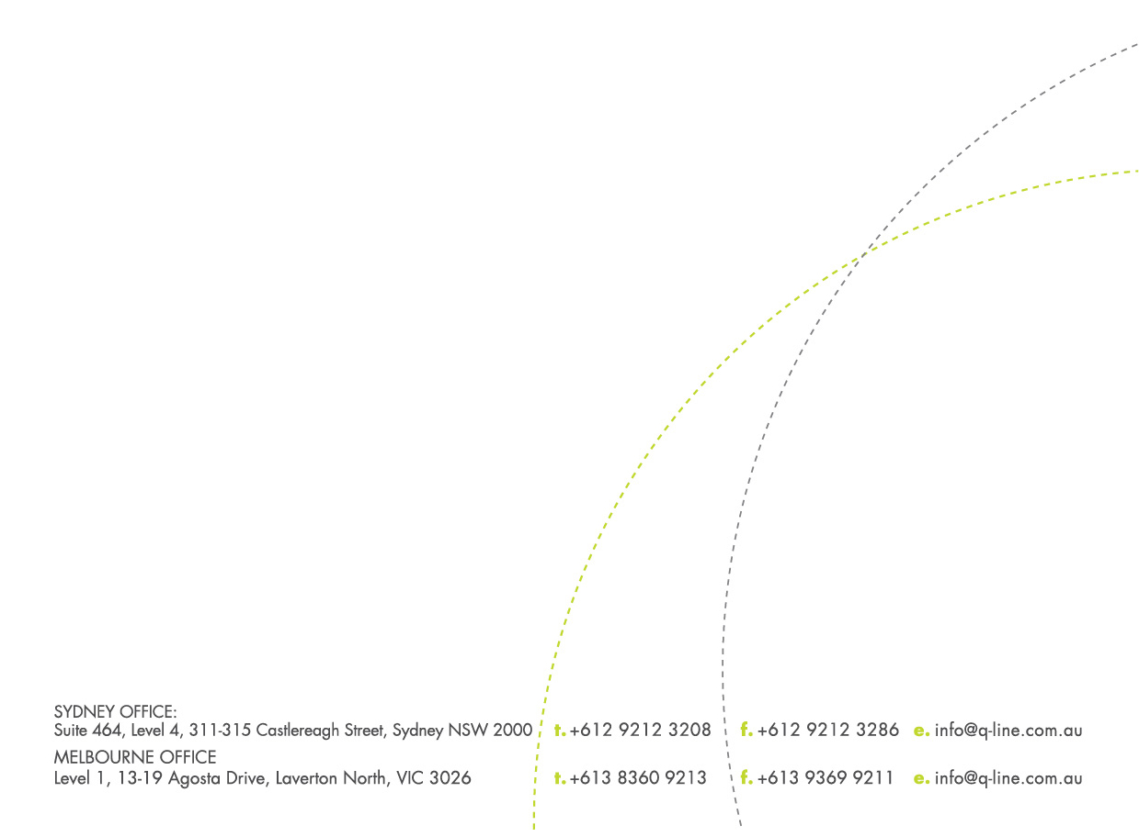
CONTAINER WEIGHT DECLARATION

Vessel Name: _______________________________________ Voyage:_________________
Container Number: ___________________________________ [ ] 20’ [ ] 40’
Weight of Cargo: _____________________________kgs
(Including packaging)
Container Weight: ____________________________kgs
(Including Tare)
Total Weight: ________________________________kgs

If weights are incorrectly declared, the exporter / importer will be responsible for any ensuing fines or costs.

Signature:______________________________________ Date: __________________________
Name of Signatory: _______________________________________________________________
Name of Responsible Entity: ________________________________________________________
Name Address / Business Address of Responsible Entity:
________________________________________________________________________________
_________________________________________________________________________________
_________________________________________________________________________________

